Instructions

Read the OSHA Standard on Eye and Face Protection. Standard Number: 1910.133

Go to this online article: What Does ANSI Z87.1 Certified Mean? and answer the following questions.

Questions:

- What does ANSI stand for?
- These standards help ensure personal eye and face protection devices provide the necessary protection from what hazards?
- The ANSI Z87.1 standard has been updated twice since 2003. What years was it updated and what was the purpose of the updates?
- ANSI Z87.1 certified safety glasses undergo intensive testing to ensure they’ll protect eyes as expected. What do the tests include?
- The article includes this video. View the video and provide a summary of the content of the video.
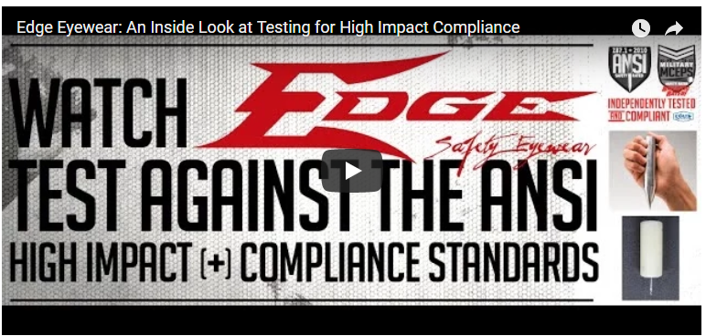

- What do the product markings mean? Copy and paste this table with your answers into your submission.

Product marking | What does it mean?
Z87+
D3
D5
W
U
R
L
Z87-2
H
V

